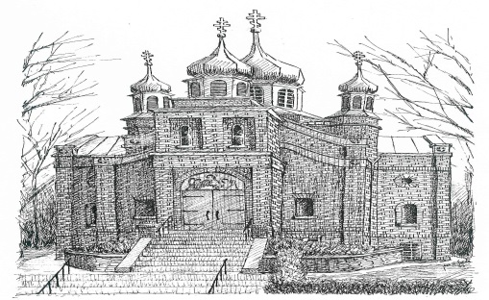

Holy Trinity Orthodox Church

Anthony Bichun Memorial Scholarship Application
2017

Name: ____________________________________________________________

Local Address: _____________________________________________________

_____________________________________________________

Phone Number: (____) ___________

High School Students: Name of High School______________________________

Graduate Students: List all undergraduate and graduate colleges attended and degrees:

___________________________________________________________________

___________________________________________________________________

___________________________________________________________________

Undergraduate Students: List all undergraduate colleges attended and number of credits completed at each:

___________________________________________________________________

___________________________________________________________________

___________________________________________________________________

What is your principal source of income: _______________________________?

Are you currently employed? __________ Job: ________________________

Please submit the following materials by May 21, 2017 to HTOC Scholarship Committee,
305 Washington St. PO BOX 2876, New Britain Ct. 06050-2876
The scholarship will be presented to the recipient(s) on June 18, 2017 after Liturgy

- Grade point average: Please submit a copy of your transcript with grades through the fall semester 2017. Students may submit unofficial transcripts printed from the university’s Website.

B. Recommendation Letters: Please submit two (2) letters of recommendations.

C. Essay: This essay should be 250 words.
Please choose one of the two
Matthew 25:34-40, Isaiah 58:6-11
How has your life and activities mirror one of these passages?

MUST INCLUDE IN THE ESSAY
Matthew 5:13-6 what ideas do you see for letting your “Lamp Shine” and helping your church grow?

In the event that I am a recipient of this scholarship and thereafter do not attend a higher education institution, I shall return the scholarship awarded to me.

Signature: _______________________________________________

Date: ____________________________

